CE382 : Advanced Web Technology D22CE157

# Practical - 1

**AIM :** Create a program that declares and initializes variables of different data types (string, number, boolean) and displays their values. Write a function that takes two numbers as parameters and returns their sum.

## Code :

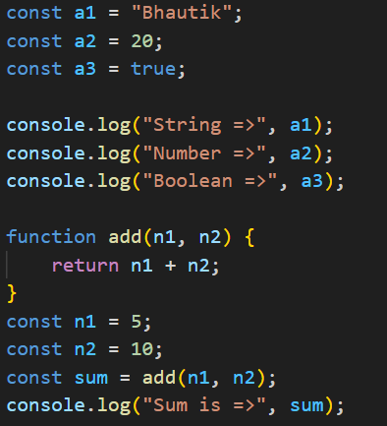

**Output:**

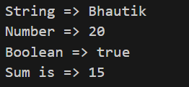

U & P U. Patel Department of Computer Engineering 1

CE382 : Advanced Web Technology D22CE157

# Practical - 2

**AIM :** Create an array of numbers and perform the following operations: => Find the length of the array.

=> Access and display specific elements using indexing.

=>Use array methods like push() ,pop(), shift(), unshift(), joindelete(),concate(),flat(),splice() and slice() to modify the array.

Create an object representing a person with properties like name, age, and gender. Implement a function that displays the person's details

## Code :

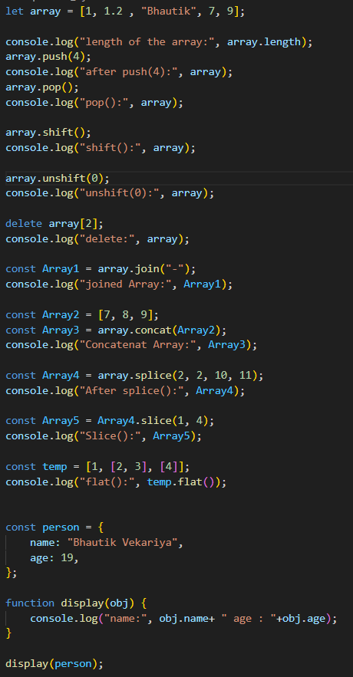

U & P U. Patel Department of Computer Engineering 2

CE382 : Advanced Web Technology D22CE157

## Output:

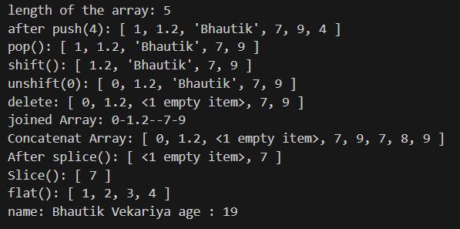

U & P U. Patel Department of Computer Engineering 3

CE382 : Advanced Web Technology D22CE157

# Practical - 3

**AIM :** Implement following features of ECMASCRIPT 6.

* The let keyword
* The const keyword
* Arrow Functions
* The (Spread Of) ... Operator
* For/of
* Map Objects
* Set Objects
* Classes
* Promises
* Symbol
* Default Parameters
* Function Rest Parameter

U & P U. Patel Department of Computer Engineering 4

CE382 : Advanced Web Technology D22CE157

## Code :

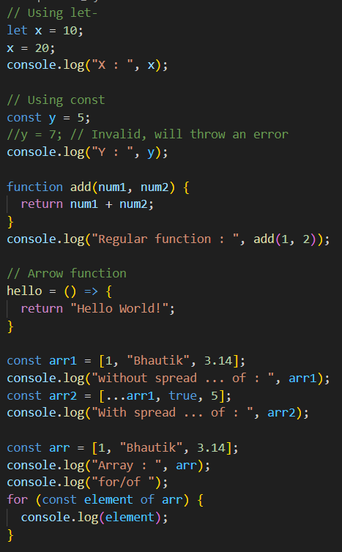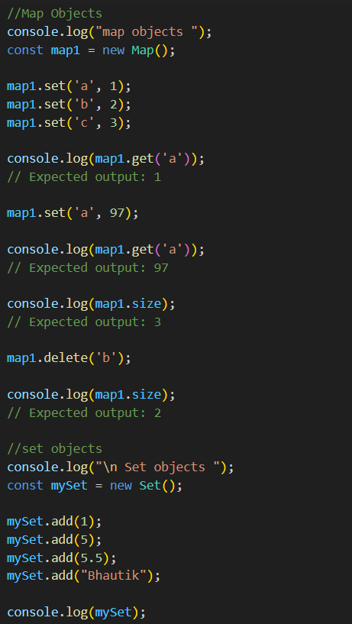

U & P U. Patel Department of Computer Engineering 5

CE382 : Advanced Web Technology D22CE157

|  |  |
| --- | --- |
|  |  |

U & P U. Patel Department of Computer Engineering 6

CE382 : Advanced Web Technology D22CE157

## Output:

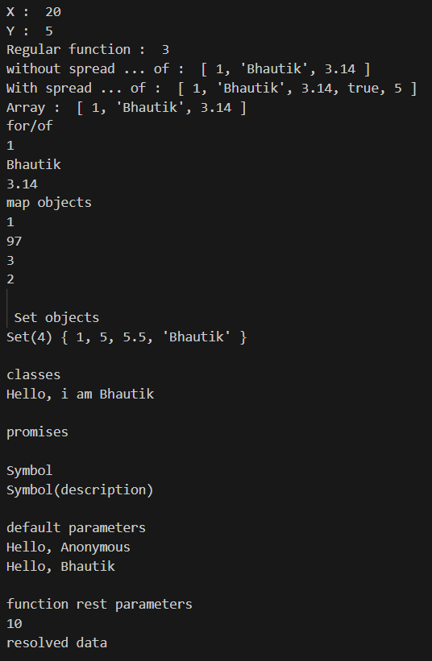

U & P U. Patel Department of Computer Engineering 7

CE382 : Advanced Web Technology D22CE157

# Practical - 4

**AIM :** Write a function that calculates the factorial of a given number using recursion. Create a nested function that performs a specific task and invoke it within another function.

## Code :

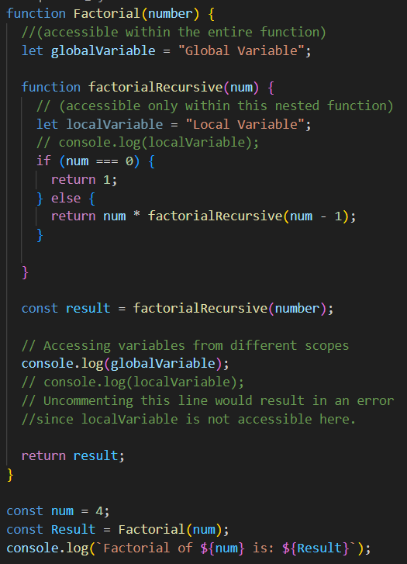

**Output:**



U & P U. Patel Department of Computer Engineering 8